 | EPROJECT  FINAL REPORT | 

ALLURING DECORS
Faculty: Nguyen Xuan Doan
BATCH: 0905E
GROUP CODE: Group 1
STUDENTS:
No | Full Name | Roll No
1 | Truong Quoc Toan | VN.040/200708/0007
2 | Nguyen Viet Thang | VN.040/200807/0048
3 | Nguyen The Anh | VN.040/200710/0043
4 | Doan Duy Trung | VN.040/200710/0105



This is to certify that members of group:
TRUONG QUOC TOAN
NGUYEN VIET THANG
NGUYEN THE ANH
DOAN DUY TRUNG
Have successfully Designed & Developed

ALLURING DECORS

Submitted by:
TRUONG QUOC TOAN
NGUYEN VIET THANG
NGUYEN THE ANH
DOAN DUY TRUNG

Date of Issue: 08/06/2011

Table of Contents
REVIEW 1 4
1. PROBLEM STATEMENT 5
2. GENERAL REQUIREMENT SPECIFICATION 5
3. FUNCTION REQUIREMENT SPECIFICATION 6
4. NON-FUNCTION REQUIREMENT SPECIFICATION 7
5. OTHER REQUIREMENT SPECIFICATION 8
6. TASKSHEET FOR REVIEW1: 8
REVIEW 2 9
1. USECASE DIAGRAM 10
2. SEQUENCE DIAGRAM 23
3. SITEMAP 32
4.ENTITIES 35
5. ENTITIES RELATIONSHIP DIAGRAM 37
6. TASKSHEET FOR REVIEW2 37
REVIEW 3 38
1. DATABASE DESIGN 39
2. DATABASE RELATIONSHIP DIAGRAM 45
3. DESIGN INTERFACE 46
4. TASKSHEET FOR REVIEW 3 58

REVIEW 1

1. PROBLEM STATEMENT
Our Client “Alluring Decors” is one of the upcoming Interior and Exterior Designers in the territory. They had been in to this profession since 5 years down the line. They deal with the Interior and Exterior Decoration of the houses, offices, shops, malls, etc. based on the contract that they had received from their clients.
Alluring Decors, in general advertise about their work through the news papers, TV advertisements, hoardings, banners, and through the internet (some other advertising websites) for which they should have to incur certain amount for advertising. Also for advertising they cannot go up to a full extent, i.e., there is a limitation in advertising either due to costing or due to the limitations of advertisement.
The Management of Alluring Decors had come up with the an idea through which they can give a much more insight about their work by including a website for their own, in which they can advertise with a full span, with images, etc. Also they introduce new tasks and they can advertise the accomplished tasks, etc. So they approached us with their idea, so that we can help them by developing a site for them through which they can implement their ideas.
For this purpose, they have approached us to develop a web site.

2. GENERAL REQUIREMENT SPECIFICATION
Website has the main following idea:
- A site needs to be designed where user will register either as a Client or Admin.
- If registered as a Client then he will be able to view the details, apply for the services offered, and check the status of the applications sent, etc.
- If registered as a Admin then he will be able to will be full rights for the user accessing the site.
- The Guest can only view the details or register with the site or login into the site or leave a feedback.

3. FUNCTION REQUIREMENT SPECIFICATION
a. The storage requirement:
- The user information: website has 3 kinds of user:
- Guest.
- Client: users who registered, website needs store their information to manage as well as supply the available functions for Client kind.
- Admin: he is the administrator of website with the highest management right.
- The property information: this is the main data of website. The properties have 3 main kinds: On-Going Projects, Up-Coming Projects, Accomplished Projects . These kinds have some general information such as price, location, city… However, depending on their kind, they have some private information such as:
- On-Going Projects: In this section list of all the project that are currently on-going are to be displayed along with the images of each, and a link “more details” accompanied with it, so as to view the detailed descriptions for that project...
- Up-Coming Projects: In this section list of all the project that are going to be taking place in the near future (i.e., the project for which the contract for the project is received, but then the project is not yet started) are to be displayed along with the images of each, and a link “more details” accompanied with it, so as to view the detailed descriptions for that project.
- Accomplished Projects: In this section list of all the project that have been completed are to be displayed along with the images of each, and a link “more details” accompanied with it, so as to view the detailed descriptions for that project.
- The FAQs information.
- Services Offered
- Domain List
- And some another sub information such as the information about the company, the modes of payment, location …
b. The business requirement:
- Guest : they can :
- View the details.
- Register with the site.
- Login into the site.
- Leave a feedback.
- Client : they can:
- Manage their personal information.
- View the details.
- Apply for the services offered.
- Check the status of the applications sent.
- Use the FAQs.
- Request Service / Manage Service Requests.
- Feedback.
- Admin: they can
- Manage the User.
- Manage the property database.
- Manage the advertisements.
- Manage the FAQs database.
- Manage, set up the parameter of system.

4. NON-FUNCTION REQUIREMENT SPECIFICATION
a. Evolution:
Website uses some techniques such as Struts, EJB, WS ... and it is always ready for upgrade, expanse the function and it also allow the administrator change the parameter and the configuration of the system easily.
b. Friendliness:
The website’ layout is clearly, friendly and easy to use with many kinds of user: user has the knowledge about information technology as well as user doesn’t have the knowledge about information technology.
c. Safeness:
- The information in the system is only edited by authorized users.
- The personal information such as profile, advertisement and the property information is only edited by the member who is the owner of that information.
- Only the administrator or the authorized users have the suitable responsibility and authority can control, manage and update the information of system.

5. OTHER REQUIREMENT SPECIFICATION
a. Hardware:
A minimum computer system that will help you access all the tools in our resource is a Pentium IV or better, 128 Megabytes of RAM or better, Window XP SP2(or higher).
b. Software:
- IE 6.0 (or higher).
- Jboss 4.0.
- SQL Server 2000.

6. TASKSHEET FOR REVIEW1:

No | Title | Start Date | Finish Date | Name
01 | Analysis | 08/06/2011 | 08/07/2011 | All of group

REVIEW 2

1. USECASE DIAGRAM
a. Diagram:
- Guest:
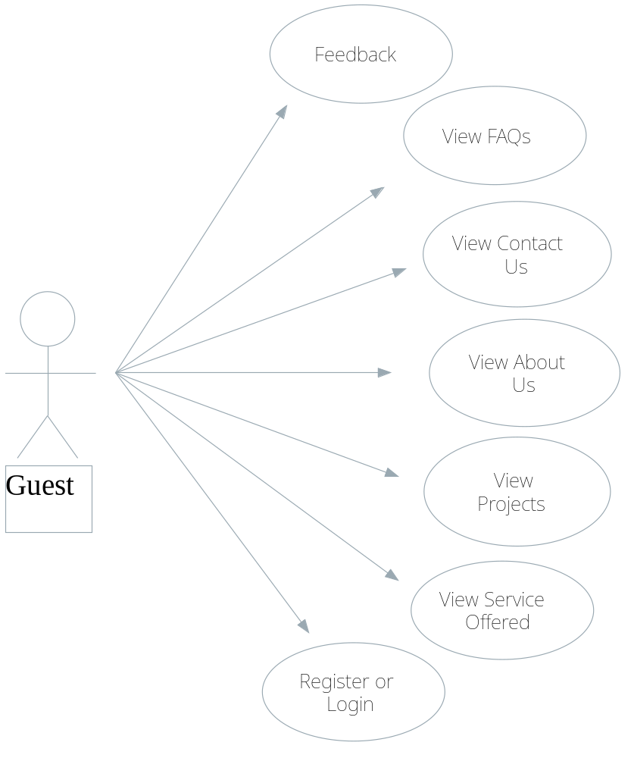
Figure 1 : Guest Diagram

- Admin:
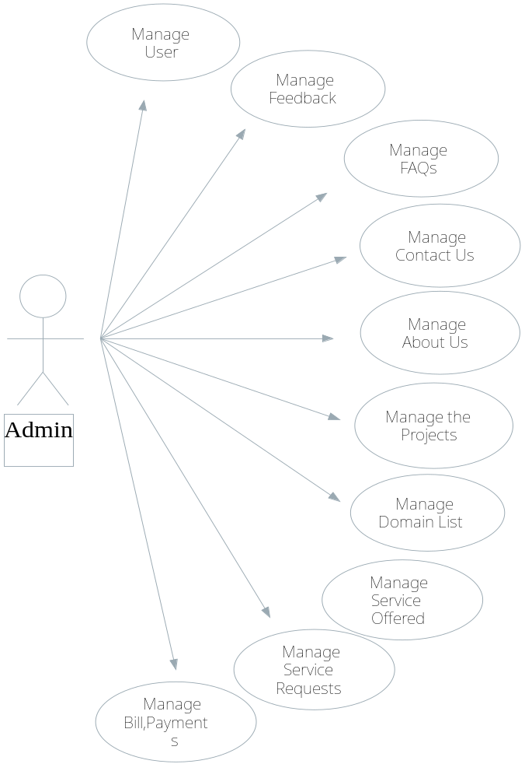
Figure 2 : Admin Diagram

- Client:
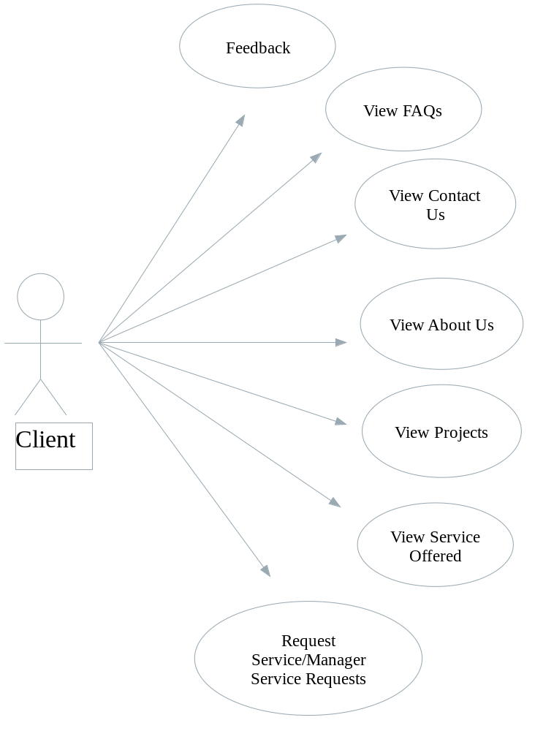
Figure 3 : Client Diagram

b. Description:
Usecase | REGISTER
Actor | Guest
Short Description | To register Member.
Pre-Conditions
Post-Conditions | New Customer account will be created.
Basic Flow | Actor action  - Actor click Register button.  - Actor fills out all information and click “submit” button. | System responses  - System display Register page with the following control:  - UserName field.  - Password field.  - Retype Password field.  - Name field.  - Address field.  - Phone field.  - Email field.  - If the UserName existed, system will warn Guest.  - System validates information and User will be added into database and send “Add successfully” message.

Usecase | LOGIN.
Actor | Guest
Short Description | To log into the system.
Pre-Conditions
Post-Conditions | - Actor will be redirected to the HomePage with the suitable function menu.
Basic Flow | Actor action  - When Actor click Login button.  - Actor fills out all information and click “submit” button. | System responses  - System will redirect them to the LogIn page with the following control:  - UserName field.  - Password field.  - If the UserName or Password is invalid, system will warn User retype.  - System redirects them to the HomPage with the suitable function menu.

Usecase | VIEW INFORMATION.
Actor | All in user.
Short Description | To view information about the newest projects, services etc.
Pre-Conditions
Post-Conditions | All details information will be shown.
Basic Flow | Actor action  - Actor chooses the information to view. | System responses  - System will show the details information.

Usecase | MANAGE FAQs.
Actor | Admin
Short Description | Manage the questions of FAQs such as Add, Edit, Delete the questions and the answers in the FAQs.
Pre-Conditions | Logged in and User’ kind is “Admin”.
Post-Conditions | If success, system will save the changes, else nothing changes.
Basic Flow | Actor action  - Actor clicks the Add button to Edit.  - Actor fills out all information and click “submit” button.  - Actor clicks the Add button to Add.  - Actor fills out all information and click “submit” button.  - Actor chooses a FAQs and clicks the Delete button to Delete this question.  - Actor clicks OK button to delete. | System responses  - System redirects Edit FAQs page with the following controls:  - Question field.  - Answer field.  - System validates his input information.  - System confirms that a new question was added.  - System updates the list of questions.  - System redirects Add FAQs page and display:  - Question field.  Answer field.  - System validates his input information.  - System confirms that a new question was added.  - System updates the list of questions.  - System confirms that Admin want to delete this question.  - System delete this question and update the list of question.

Usecase | FEEDBACK.
Actor | Client,Guest
Short Description | User must be able to give feedbacks about the site or ask the queries if any
Pre-Conditions
Post-Conditions | If success, system will save the changes, else nothing changes.
Basic Flow | Actor action  - When Actor clicks the Feedback.  - Actor fills out all information and click “submit” button. | System responses  - System will redirect them to the Feedback page with the following controls:  - FullName field.  - Email field.  - Feedback content field.  - If the content is empty or invalid, system will warn User retype.  - System redirects them to the HomPage with the suitable function menu.

Usecase | MANAGE PROJECTS.
Actor | Admin
Short Description | Manage the project such as Add, Edit, Delete in three categories(Project type): On-Going Projects, Upcoming Projects, and Accomplished Projects.
Pre-Conditions | Logged in and User’ kind is “Admin”.
Post-Conditions | If success, system will save the changes, else nothing changes.
Basic Flow | Actor action  - Admin chooses a project and clicks the Edit button to Edit:  - Actor fills out all information and click “submit” button.  - Admin clicks the Add button to Add.  - Actor fills out all information and click “submit” button.  - Actor chooses a project and clicks the Delete button to Delete this question.  - Actor clicks OK button to delete. | System responses  - System will redirect them to the Edit Project page with the following controls:  - Name field.  - Description field.  - Images field.  - Project Type field.  - System validates his input information.  - System confirms that the change saved.  - System updates the list of project.  - System will redirect them to the Add Project page with the following controls:  - Name field.  - Description field.  - Images field.  - Project Type field.  - System validates his input information.  - System confirms that the change saved.  - System updates the list of project.  - System confirms that Admin want to delete this question.  - System delete this question and update the list of question.

Usecase | MANAGE SERVICES.
Actor | Admin
Short Description | Manage the project such as Add, Edit, Delete the services based on the domains(say catagories).
Pre-Conditions | Logged in and User’ kind is “Admin”.
Post-Conditions | If success, system will save the changes, else nothing changes.
Basic Flow | Actor action  - Actor chooses a service and clicks the Edit button to Edit.  - Actor fills out all information and click “submit” button.  - Admin clicks the Add button to Add.  - Actor fills out all information and click “submit” button.  - Actor chooses a service and clicks the Delete button to Delete this service.  - Actor clicks OK button to delete. | System responses  - System will redirect them to the Edit Service page with the following controls:  - Name field.  - Description field.  - Images field.  - Project Type field.  - System validates his input information.  - System confirms that the change saved.  - System updates the list of service.  - System will redirect them to the Add Service page with the following controls:  - Name field.  - Description field.  - Images field.  - Project Type field.  - System validates his input information.  - System confirms that the change saved.  - System updates the list of service.  - System confirms that Admin want to delete this service.  - System delete this question and update the list of service.

Usecase | MANAGE ABOUT US.
Actor | Admin
Short Description | Manage such as Edit details of About us.
Pre-Conditions | Logged in and User’ kind is “Admin”.
Post-Conditions | If success, system will save the changes, else nothing changes.
Basic Flow | Actor action  - Actor chooses a information of About Us and clicks the Edit button to Edit.  - Actor fills out all information and click “submit” button. | System responses  - System will redirect them to the Edit About Us page with the following controls:  - Introduction field.  - Description field.  - System validates his input information.  - System confirms that the change saved.  - System updates the information of About Us.

Usecase | MANAGE CONTACT US.
Actor | Admin
Short Description | Manage such as Add,Delete,Edit details like address, phone,ect. of the company.
Pre-Conditions | Logged in and User’ kind is “Admin”.
Post-Conditions | If success, system will save the changes, else nothing changes.
Basic Flow | Actor action  - Actor chooses a information of Contact Us and clicks the Edit button to Edit.  - Actor fills out all information and click “submit” button.  - Admin clicks the Add button to Add.  - Actor fills out all information and click “submit” button.  - Actor chooses a information of Contact Us and clicks the Delete button to Delete this information.  - Actor clicks OK button to delete. | System responses  - System will redirect them to the Edit Contact Us page with the following controls:  - Introduction field.  - Description field.  - System validates his input information.  - System confirms that the change saved.  - System updates the information of Contact Us.  - System will redirect them to the Add Contact Us page with the following controls:  - Introduction field.  - Description field.  - System validates his input information.  - System confirms that the change saved.  - System updates the information of Contact Us.  - System confirms that Actor want to delete this information of Contact Us.  - System updates the information of Contact Us.

Usecase | MANAGE USER.
Actor | Admin.
Short Description | Manage the User such as Delete the information of User.
Pre-Conditions | Logged in and User’ kind is “Admin”.
Post-Conditions | If success, system will save the changes, else nothing changes.
Basic Flow | Actor action  - Actor chooses a information of User and clicks the Delete button to Delete this information.  - Actor clicks OK button to delete. | System responses  - System confirms that Actor want to delete this information of User.  - System updates the information of User.

Usecase | MAKE REQUEST.
Actor | Client.
Short Description | User must be able to send request.
Pre-Conditions
Post-Conditions | If success, system will save the changes, else nothing changes.
Basic Flow | Actor action  - Actor clicks the Add button to Edit Request.  - Actor fills out all information and click “submit” button to send request.  - Actor clicks the Add button to Add Request.  - Actor fills out all information and click “submit” button to send request.  - Actor chooses a Request and clicks the Delete button to Delete this information.  - Actor clicks OK button to delete. | System Reponses  - System will redirect them to the Edit Request page with the following controls:  - Request content field.  - System validates his input information.  - System confirms that the send request.  - System updates the information of Request.  - System will redirect them to the Add Request page with the following controls:  - Request content field.  - System validates his input information.  - System confirms that the send request.  - System updates the information of Request.  - System confirms that Actor want to delete this Request.  - System updates the list of Request.

2. SEQUENCE DIAGRAM
a. Login Sequence Diagram:
Return whether guest is a member or not. If not, asks guest to re-enter Username and password.
Click login button
Login.jsp
doPost()
Login.java
Validate username, password
UserDetailDao,java
(session bean)
getUserByUsernameAndPassword()
Database
Return object UserDetail if found
Guest

b. Register Sequence Diagram:
Return whether guest register success or not.
Click registry button
Register.jsp
doPost()
Register.java
Validate user information
UserDetailDao,java
(session bean)
add()
Guest
Database

c. Feedback Sequence Diagram:
Return whether guest send feedback success or not.
Click submit button
FeedBack.jsp
doPost()
FeedBack.java
Validate FeedBack information
FeedBackDao,java
(session bean)
add()
Guest
Database

d. Make Service Request Sequence Diagram:
*Require:Login*
Return whether client request service success or not.
Click submit button
Request.jsp
doPost()
Request.java
Validate Request information
RequestDao,java
(session bean)
add()
Client
Database

e. Update Service Request Sequence Diagram:
*Require:Login*
Return whether client update request success or not.
Click update button
doPost()
Validate Request information
update()
Client
Database
ClientRequestManage.jsp
ClientRequestManage.java
RequestDao,java
(session bean)

f. Cancel Service Request Sequence Diagram:
*Require:Login*
Return whether client cancel request success or not.
Click cancel button
doPost()
Validate Request information
cancel()
Client
Database
ClientRequestManage.jsp
ClientRequestManage.java
RequestDao,java
(session bean)

g. Create new Project Type Sequence Diagram:
*Require:Login*
Return whether adding new project type success or not.
Click create button
doPost()
add()
Admin
Database
CreateProjectType.jsp
CreateProjectType.java
ProjectTypeDao,java
(session bean)
Validate projecttype information

h. Update Project Type Sequence Diagram:
*Require:Login*
Return whether updating project type success or not.
Click update button
doPost()
Validate project type information
update()
Admin
Database
ProjectTypeMange.jsp
ProjectTypeMange.java
ProjectTypeDao,java
(session bean)

i. Create new Project Sequence Diagram:
*Require:Login*
Return whether adding new project success or not.
Click create button
doPost()
Validate project information
add()
Admin
Database
CreateProject.jsp
CreateProject.java
ProjectDao,java
(session bean)

j. Update Project Sequence Diagram:
*Require:Login*
Return whether updating project type success or not.
Click update button
doPost()
Validate project information
update()
Admin
Database
ProjectMange.jsp
ProjectMange.java
ProjectDao,java
(session bean)

k. Create new Domain Sequence Diagram:
*Require:Login*
Return whether adding new domain success or not.
Click create button
doPost()
Validate domain information
DomainDao,java
(session bean)
add()
Admin
Database
CreateDomain.jsp
CreateDoamin.java

l. Update Domain Sequence Diagram:
*Require:Login*
Return whether updating domain success or not.
Click update button
doPost()
Validate domian information
update()
Admin
Database
DomainMange.jsp
DomainMange.java
DomainDao,java
(session bean)

m. Create new Service Sequence Diagram:
*Require:Login*
Return whether adding new service success or not.
Click create button
doPost()
Validate Service information
ServiceDao,java
(session bean)
add()
Admin
Database
CreateService.jsp
CreateService.java

n. Update Service Sequence Diagram:
*Require:Login*
Return whether updating Service success or not.
Click update button
doPost()
Validate Service information
update()
Admin
Database
ServiceMange.jsp
ServiceMange.java
ServiceDao,java
(session bean)

o. Update Service Request Status Sequence Diagram:
*Require:Login*
Return whether admin update request success or not.
Click update button
doPost()
Validate Request information
update()
Admin
Database
AdminRequestManage.jsp
AdminRequestManage.java
RequestDao,java
(session bean)

p. Create new Payment Detail Sequence Diagram:
*Require:Login*
Return whether adding new payment success or not.
Click create button
doPost()
Validate Payment information
PaymentDao,java
(session bean)
add()
Admin
Database
CreatePayment.jsp
CreatePayment.java

q. Update Payment Detail Sequence Diagram:
*Require:Login*
Return whether updating payment success or not.
Click update button
doPost()
Validate Payment information
PaymentDao,java
(session bean)
update()
Admin
Database
PaymentManage.jsp
PaymentManage.java

3. SITEMAP
a. For Guest:
Project

Hello
Every
Body
…
Feedback

Hello
Every
Body
…
About Us

Hello
Every
Body
…
Register

Hello
Every
Body
…
Home

Hello
Every
Body
…
End

Hello
Every
Body
…
Login

Hello
Every
Body
…
Contact Us

Hello
Every
Body
…
Service Offered

Hello
Every
Body
…
FAQs

Hello
Every
Body
…

b. For Admin:
Manage FAQs

Hello
Every
Body
…
Manage Feedback

Hello
Every
Body
…
Manage Service Request/Status

Hello
Every
Body
…
Manage Bill Details

Hello
Every
Body
…
End

Hello
Every
Body
…
Home

Hello
Every
Body
…
Login

Hello
Every
Body
…
Manage Project

Hello
Every
Body
…
Manage About Us

Hello
Every
Body
…
Manage Contact Us

Hello
Every
Body
…
Manage User

Hello
Every
Body
…
Manage Service

Hello
Every
Body
…
Manage Domain List

Hello
Every
Body
…
Edit

Hello
Every
Body
…
Add

Hello
Every
Body
…
Delete

Hello
Every
Body
…

c. For Client:
FAQs

Hello
Every
Body
…
Project

Hello
Every
Body
…
About Us

Hello
Every
Body
…
Home

Hello
Every
Body
…
Login

Hello
Every
Body
…
Contact Us

Hello
Every
Body
…
Service Offered

Hello
Every
Body
…
Service Request

Hello
Every
Body
…
Feedback

Hello
Every
Body
…
Register

Hello
Every
Body
…
End

Hello
Every
Body
…

4.ENTITIES

User
FullName
Status
Phone
Address
Password
Email

Name
Image
Description
Project
Order

Payment
Orderdate
Status
Begindate
TotalPayment
Email

Question
Answer
FAQs

Feedback

Comment
Datecreate
Address
Phone
Fullname
Email
Name
Description
Service
Datecreate
Introdution
ContactUs

5. ENTITIES RELATIONSHIP DIAGRAM

User
Payment
Have
Have
Order
FAQs
Feedback
ContactUs
Project
Service
N
1
1
N

6. TASKSHEET FOR REVIEW2
No | Title | Start Date | Finish Date | Name
01 | Use case and Descriptor | 18/06/2011 | 28/06/2008 | All of group
02 | Sitemap | 18/06/2011 | 28/06/2008 | All of group
03 | Entities | 18/06/2011 | 28/06/2008 | All of group
04 | ERD | 18/06/2011 | 28/06/2008 | All of group
05 | Sequence Diagram | 18/06/2011 | 28/06/2008 | Quoc Toan

REVIEW 3

1. DATABASE DESIGN
- Table FAQ:
tblFAQ
Field name | Data type | Null | Default value | Table-ref field | Key | Description
Id | Int | NO |  |  | PK | Identity(1, 1).
Question | Nvarchar(500) | NO
Answer | Nvarchar(1000) | NO

tblPageContact
Field name | Data type | Null | Default value | Table-ref field | Key | Description
Id | Int | NO |  |  | PK | Identity(1, 1).
Introdution | Nvarchar(4000) | NO |  |  |  | Contact information.
- Table PageContact:

- Table Feedback:
tblFeedback
Field name | Data type | Null | Default value | Table-ref field | Key | Description
Id | Int | NO |  |  | PK | Identity(1, 1).
Fullname | Nvarchar(100) | NO |  |  |  | User’s name.
Email | Nvarchar(70) | Yes |  |  |  | User’s email.
Comment | Nvarchar(2000) | NO |  |  |  | Feedback content.
Datecreate | Nvarchar(10) | NO |  |  |  | Date that feedback was created.

- Table AboutUs:
tblAboutus
Field name | Data type | Null | Default value | Table-ref field | Key | Description
Id | Int | NO |  |  | PK | Identity(1, 1).
Introdution | Nvarchar(4000) | NO |  |  |  | About us information

- Table ProjectType:
tblProjectType
Field name | Data type | Null | Default value | Table-ref field | Key | Description
Id | Int | NO |  | tblProject | PK | Identity(1, 1)
ProjectTypeName | Nvarchar(100) | NO |  |  |  | Name of the project type

- Table Project:
tblProject
Field name | Data type | Null | Default value | Table-ref field | Key | Description
Id | Int | NO |  |  | PK | Identity(1, 1)
ProjectName | Nvarchar(100) | NO |  |  |  | Name of project
Description | Nvarchar(100) | Yes |  |  |  | explanation of project
Image | Nvarchar(100) | Yes |  |  |  | Image for the project
ProjectTypeID | Int | NO |  | tblProjectType | FK | Name of the project type

- Table Level:
tblLevel
Field name | Data type | Null | Default value | Table-ref field | Key | Description
Id | Int | NO |  | tblUserDetail | PK | Identity(1, 1)
LevelName | Nvarchar(100) | NO |  |  |  | Name of level(role)

- Table UserDetail:
tblUserDetail
Field name | Data type | Null | Default value | Table-ref field | Key | Description
Id | Int | NO |  |  | PK | Identity(1, 1)
Email | Nvarchar(100) | NO |  | tblRequest |  | User’ email(username)
Password | Nvarchar(100) | NO |  |  |  | User’s password
FullName | Nvarchar(100) | NO |  |  |  | Name of user
Sex | Bit | Yes | Yes |  |  | User’s sex
DateBirth | Nvarchar(100) | Yes |  |  |  | User’s birthdate
Address | Nvarchar(100) | NO |  |  |  | User’s address
Phone | Nvarchar(100) | Yes |  |  |  | User’s phone number
LevelID | Int | NO | 2 | tblLevel | FK | The level(role) of the user
IsActive | Bit | NO | Yes |  |  | Name of the project type

- Table Domain:
tblDomain
Field name | Data type | Null | Default value | Table-ref field | Key | Description
Id | Int | NO |  | tblService | PK | Identity(1, 1)
DomainName | Nvarchar(100) | NO |  |  |  | Name of domain

- Table Service:
tblService
Field name | Data type | Null | Default value | Table-ref field | Key | Description
Id | Int | NO |  |  | PK | Identity(1, 1)
ServiceName | Nvarchar(100) | NO |  |  |  | Name of service
Description | Nvarchar(2000) | Yes |  |  |  | explanation for service
Image | Nvarchar(100) | Yes |  |  |  | Image for the service
Price | decimal(18, 2) | Yes |  |  |  | Price for the service
DomainID | Int | NO |  | tblDomain | FK | Domain that the service belong to

- Table Request:
TblRequest
Field name | Data type | Null | Default value | Table-ref field | Key | Description
Id | Int | NO |  | tblRequestDetail, tblPayment | PK | Identity(1, 1).
Email | Nvarchar(70) | NO |  | tblUserDetail | FK | User’s email(username).
Location | Nvarchar(100) | Yes |  |  |  | explanation for service.
Note | Nvarchar(300) | Yes |  |  |  | Note for request.
TotalPayment | decimal(18, 2) | Yes | 0 |  |  | Total payment of the request.
TotalPaidAmount | decimal(18, 2) | Yes | 0 |  |  | Total paid amount( amount was paid by client for the request).
DateRequest | Nvarchar(10) | NO |  |  |  | Date that the request was created.
DateBegin | Nvarchar(10) | Yes |  |  |  | Date that the request will begin.
DateComplete | Nvarchar(10) | Yes |  |  |  | Date that the request will complete.
Status | Nvarchar(30) | NO |  |  |  | Domain that the service belong to.

- Table RequestDtail:
tblRequestDetail
Field name | Data type | Null | Default value | Table-ref field | Key | Description
Id | Int | NO |  |  | PK | Identity(1, 1)
RequestID | Int | NO |  | tblRequest | FK | The request that detail belong to.
ServiceID | Int | NO |  |  |  | The service(detail) that client requested.
Payment | decimal(18, 2) | Yes |  |  |  | Payment for each detail(service).

- Table payment:
tblPayment
Field name | Data type | Null | Default value | Table-ref field | Key | Description
Id | Int | NO |  |  | PK | Identity(1, 1)
RequestID | Int | NO |  | tblRequest | FK | The request that payment belong to.
PaidAmount | decimal(18, 2) | Yes |  |  |  | Amount was paid by client.
Date | Nvarchar(10) | Yes |  |  |  | Date that amount was paid.

2. DATABASE RELATIONSHIP DIAGRAM

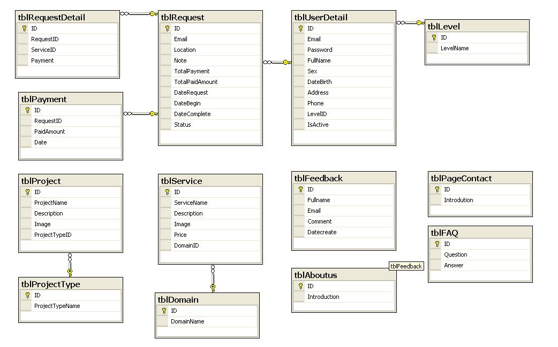

3. DESIGN INTERFACE
- Home page:
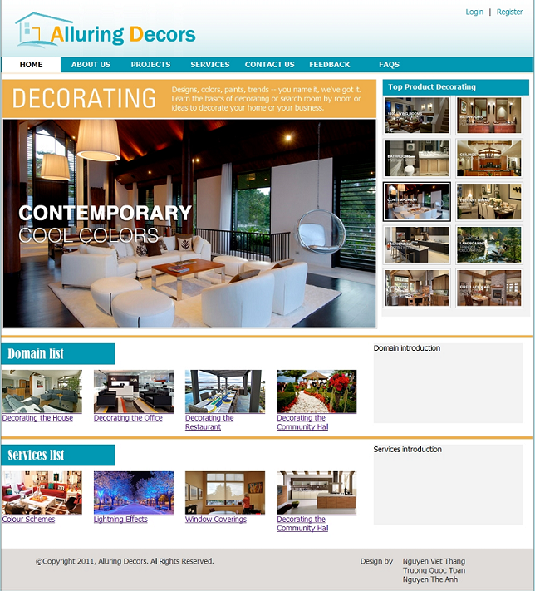
- Login page.

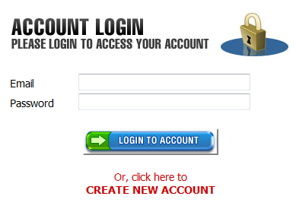
❶
❷❷❷
❸❷❷
❹❹❹❷

Screen Description:
No. | Name | Type | Validation | Event | Description
1 | email | TextField |  |  | Input email.
2 | password | TextField |  |  | Input password.
3 | submit | Button |  | Click | Show warning if the input information is invalid, else redirect User to MainPage for Customer.
4 | Create new account | Link | Required | Click | Redirect Guest to the Register Page.

- Register page.

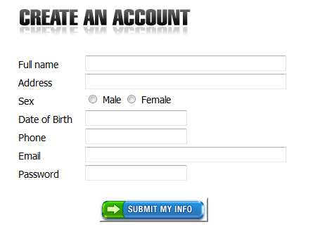
❶
❷❶
❸
❹
❺
❻
❼
❽

Screen Description:
No. | Name | Type | Validation | Event | Description
1 | fullname | TextField |  |  | Input Full name.
2 | address | TextField |  |  | Input address.
3 | sex | Radio Button |  | Click | Choose Male or Female.
4 | datebirth | TextField |  |  | Input date of birth.
5 | phone | TextField |  |  | Input phone number.
6 | email | TextField |  |  | Input email.
7 | password | TextField |  |  | Input password.
8 | submit | Button |  | Click | Show warning if the input information is invalid, else redirect User to MainPage for Customer.
- Manage FAQs.
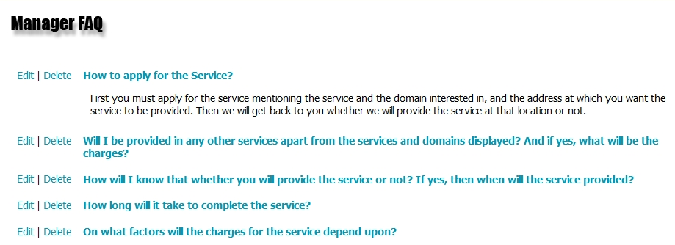
❶
❷

Screen Description:
No. | Name | Type | Validation | Event | Description
1 | Edit | Link |  | Click | Redirect User to the EditFAQ page.
2 | Delete | Link |  | Click | Delete this FAQ.

- Add new FAQs.

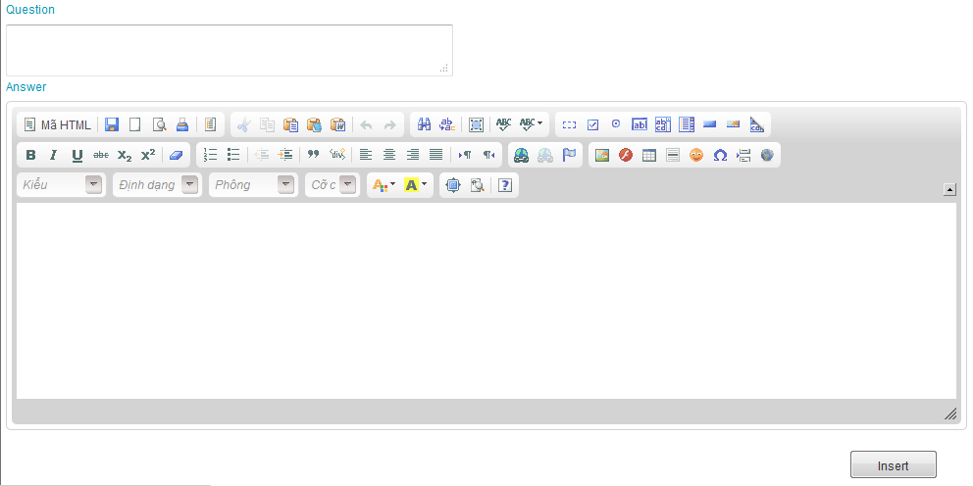
❶
❷
❸

Screen Description:
No. | Name | Type | Validation | Event | Description
1 | question | Text area |  |  | Input question.
2 | editor1 | Text area |  |  | Input answer.
3 | submit | button |  |  | Insert this FAQ.

- Add new Project.
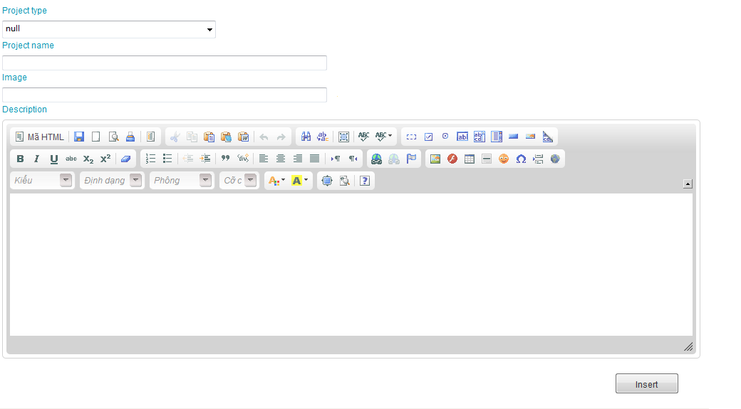
❶
❷
❸
❹
❺

Screen Description:
No. | Name | Type | Validation | Event | Description
1 | projecttype | Menubox |  | Click | Choose project type.
2 | projectname | Text area |  |  | Input Project name.
3 | image | Text area |  |  | Input image.
4 | editor1 | Text area |  |  | Input description of project.
5 | submit | Text area |  |  | Insert this project.

- Manage Project.
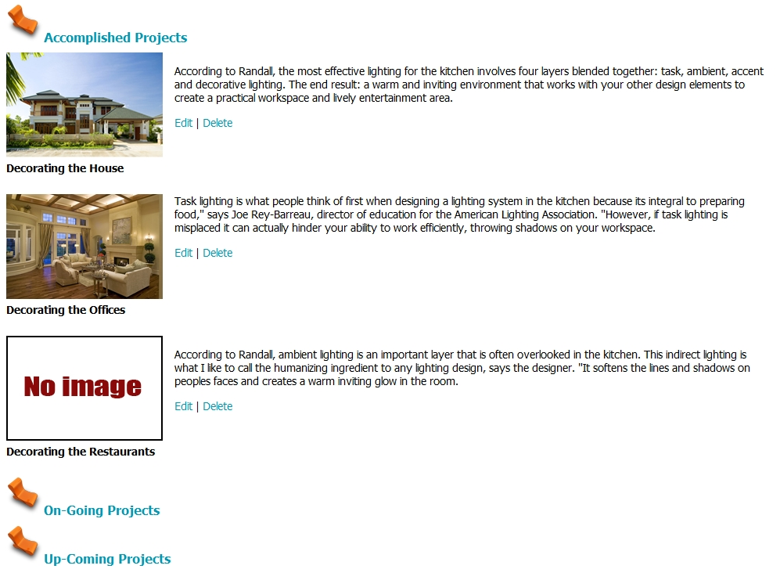
❶
❷

Screen Description:
No. | Name | Type | Validation | Event | Description
1 | edit | Link |  | Click | Choose project type.
2 | delete | Link |  | Click | Delete this project.
- Feedback page.
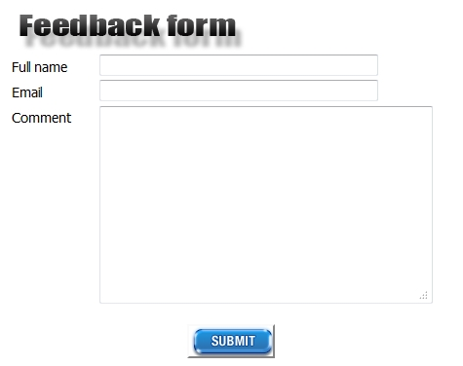
❶
❷
❸
❹

Screen Description:
No. | Name | Type | Validation | Event | Description
1 | fullname | Text field |  |  | Input Full name.
2 | email | Text field |  |  | Input email.
3 | feedback | Text area |  |  | Input content Feedback.
4 | submit | Button |  | Click | Send feedback.

- Manage Feedback page.
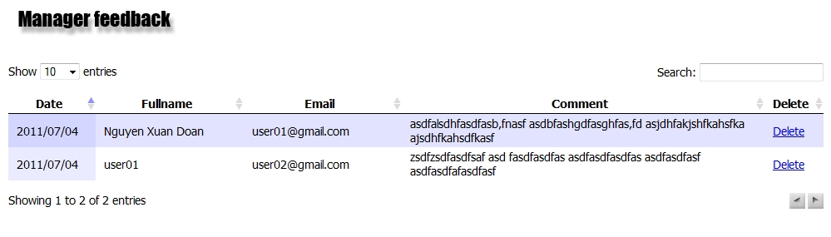
❶
❷

Screen Description:
No. | Name | Type | Validation | Event | Description
1 | search | Text field |  |  | Input Full name.
2 | delete | Link |  | Click | Delete this feedback.

- Manage Service.
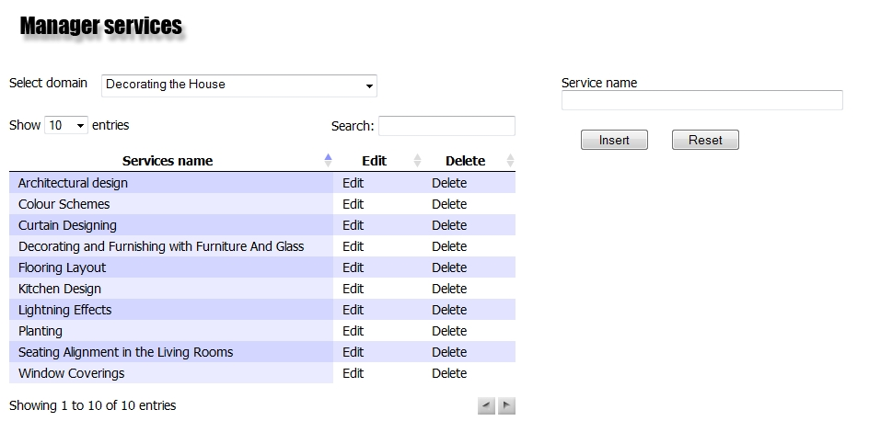
❶
❷
❸
❹
❺
❻
❼

Screen Description:
No. | Name | Type | Validation | Event | Description
1 | domainlist | Menubox |  | Click | Choose Domain
2 | search | TextField |  |  | Input Service name to search.
3 | service | Text field |  |  | Input Service name to insert or update.
4 | submit | Button |  | Click | Insert service.
5 | submit | Button |  | Click | Reset search’s field to the default value.
6 | edit | Link |  | Click | Edit Service you choose.
7 | delete | Link |  | Click | Delete this service you choose.

- Add contact.
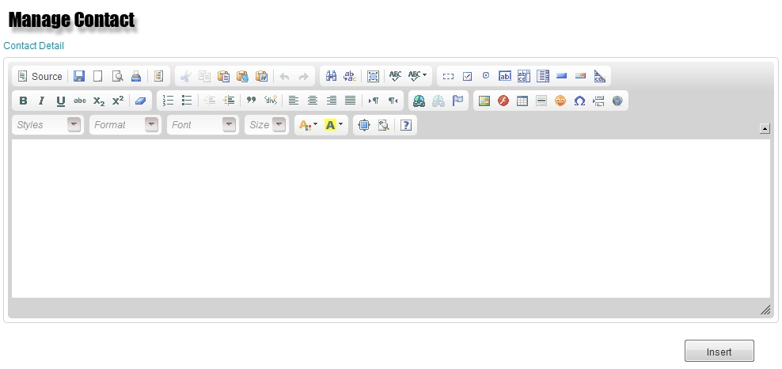
❶
❷

Screen Description:
No. | Name | Type | Validation | Event | Description
1 | editor1 | Text area |  |  | Input content of Contact.
2 | insert | Button |  | Click | Insert contact.

- Manage Domain.
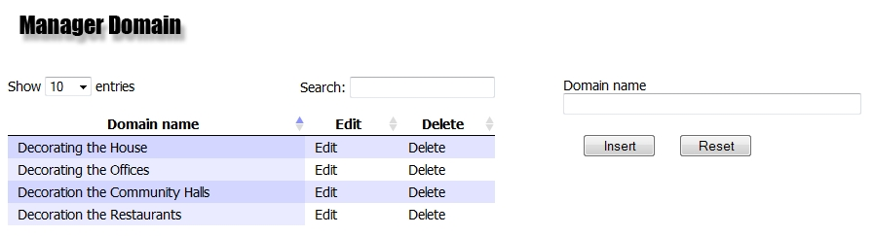
❶
❷
❹
❺
❻
❼

Screen Description:
No. | Name | Type | Validation | Event | Description
1 | domainlist | Menubox |  | Click | Choose Domain
2 | search | TextField |  |  | Input Domain name to search.
3 | domain | Text field |  |  | Input Domain name to insert or update.
4 | submit | Button |  | Click | Insert Domain.
5 | submit | Button |  | Click | Reset search’s field to the default value.
6 | edit | Link |  | Click | Edit Domain you choose.
7 | delete | Link |  | Click | Delete this Domain you choose.

4. TASKSHEET FOR REVIEW 3
No | Title | Start Date | Finish Date | Name
01 | - Database Design | 28/06/2011 | 08/07/2011 | All of group
02 | - Database Relationship Diagram | 28/06/2011 | 08/07/2011 | All of group
03 | - Design Interface | 28/06/2011 | 08/07/2011
 | - Main page for Guest | 28/06/2011 | 08/07/2011 | Viet Thang
 | - Main page for Admin | 28/06/2011 | 08/07/2011 | Viet Thang
 | - Main page for Client | 28/06/2011 | 08/07/2011 | Viet Thang
 | - Login page | 28/06/2011 | 08/07/2011 | The Anh
 | - Register page | 28/06/2011 | 08/07/2011 | Viet Thang
 | - FAQs page | 28/06/2011 | 08/07/2011 | Quoc Toan
 | - ManageFAQs page | 28/06/2011 | 08/07/2011 | Quoc Toan
 | - Project page | 28/06/2011 | 08/07/2011 | All of group
 | - ManageProject page | 28/06/2011 | 08/07/2011 | All of group
 | - Feedback page | 28/06/2011 | 08/07/2011 | All of group
 | - ManageFeedback page | 28/06/2011 | 08/07/2011 | All of group
 | - Service page | 28/06/2011 | 08/07/2011 | All of group
 | - ManageService page | 28/06/2011 | 08/07/2011 | All of group
 | - Domain page | 28/06/2011 | 08/07/2011 | All of group
 | - ManageDomain page | 28/06/2011 | 08/07/2011 | All of group
 | - ContactUs page | 28/06/2011 | 08/07/2011 | All of group
 | - Manage ContactUs page | 28/06/2011 | 08/07/2011 | All of group
 | - AboutUs page | 28/06/2011 | 08/07/2011 | All of group
 | - Manage AboutUs | 28/06/2011 | 08/07/2011 | All of group
 | - Manage User | 28/06/2011 | 08/07/2011 | All of group

